

|  |  |  |  |  |
| --- | --- | --- | --- | --- |
| 190 Elizabeth St. Toronto, ON M5G2C4 |  | p. 647-926-9724 (Tech support) |  | medlysupport@ehealthinnovcation.org |

CHF Medly + Fitbit Setup & FAQ

December 15, 2017

Version 0.2

Table of Contents

1. Phone Hardware Compatibility 2
2. Fitbit Setup 4
3. Appendix A: Fitbit Hardware Labelling 10
4. Appendix B: Fitbit Account Username + Password Generation Procedure 12

# Phone Hardware Compatibility

## iOS

The current release of Medly is compatible for any iOS device running iOS v9.3.5 or above.

There are no additional hardware requirements for supporting Medly + Fitbit (Fitbit runs on iOS v9 or above)

You may need to verify the device is updated to the most recent version of iOS supported by that device to run Medly.

iOS 9 is compatible with these devices. 
iPhone 
aaa 
iPhone 5c 
iPad 
iPad Air 2 
iPad 2 
iPad mini 3 
iPod 
iPod touch 5th 
generation 
iPhone 4s 
iPhone 5s 
iPhone 5 
iPhone 6 
iPhone 6 Plus 
iPad Air 
iPad 3rd generation 
iPad mini 2 
iPad 4th generation 
iPad mini The following is a list of devices that support iOS v9.3.5 and above:

### iPhones

* iPhone 4S
* iPhone 5
* iPhone 5S
* iPhone 5C
* iPhone SE
* iPhone 6 + 6 Plus
* iPhone 6S + 6S Plus
* iPhone 7 + 7 Plus
* iPhone 8 + 8 Plus
* iPhone X

### iPad

* iPad Air
* iPad Air 2
* iPad Mini
* iPad Mini 2
* iPad Mini 3
* iPad Mini 4
* iPad 2
* iPad 3rd Generation
* iPad 4th Generation
* iPad 5th Generation
* iPad Pro (all)

### iPad

* iPod Touch 5th Generation
* iPod Touch 6th Generation

Figure 1: iPhones that run the bare minimum iOS 9.3.x but not anything newer

## Android

Activity trackers are not supported for any current release of Medly.

iOS 9 is compatible with these devices. 
iPhone 
aaa 
iPhone 5c 
iPad 
iPad Air 2 
iPad 2 
iPad mini 3 
iPod 
iPod touch 5th 
generation 
iPhone 4s 
iPhone 5s 
iPhone 5 
iPhone 6 
iPhone 6 Plus 
iPad Air 
iPad 3rd generation 
iPad mini 2 
iPad 4th generation 
iPad mini 

Figure 2: iPads that run the bare minimum iOS 9.3.x but not anything newer

# Fitbit Setup

### 

## Device Setup: Patient Owned Fitbit

The following are instructions unique to setting up a patient owned Fitbit.

1. Verify model. Should be Charge HR, Charge 2 or Alta HR.
   * N.B. both the heart-rate and non-heart rate models look very similar. The easiest way to verify heart-rate functionality is to look on the inside of the band for the heart-rate detection LEDs (see Figure 4).

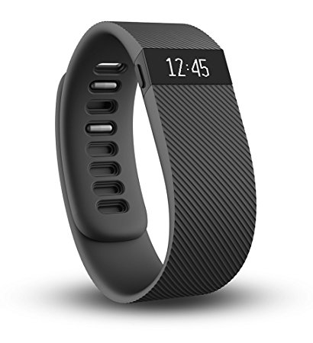

Figure 3: Charge HR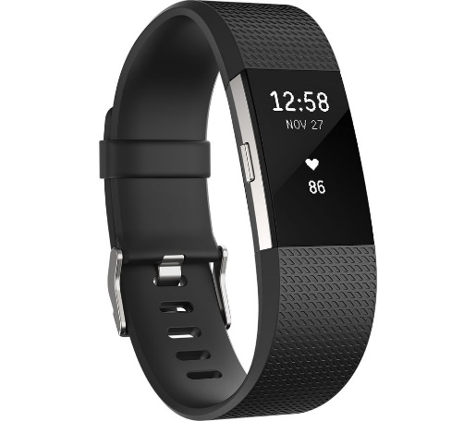

Figure 4: Charge 2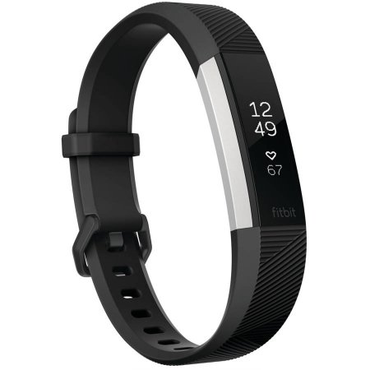

Figure 5: Alta HR

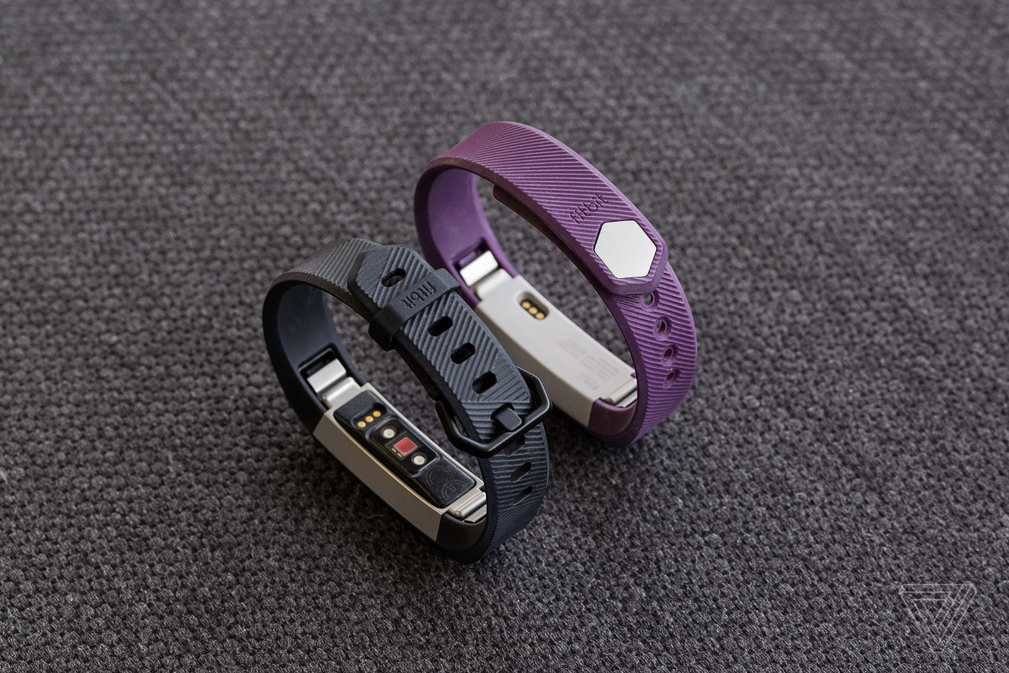

Figure 6: Alta HR (left), regular Alta (right)

1. Determine if patient owns a Fitbit account
2. Determine if patient has connected Fitbit to patient-owned account (and is willing to provide account credentials)
3. Consult Table 1: Device & Account Provision Matrix to determine whether to use patient device and if a clinic-owned Fitbit account should be generated.
   1. In the case where the patient account is to be used, the patient must either provide their account credentials to tech support or personally enter their credentials in step 8) of the account linking process detailed in the Medly + Fitbit Account Linking: Dashboard section.

Table 1: Device & Account Provision Matrix

|  |  |  |  |  |  |
| --- | --- | --- | --- | --- | --- |
| Fitbit Owned by: | Patient has Fitbit Account | Patient Has Connected Their Device to Their Account: | Is patient willing to provide account credentials? | Device to Use | Account to Use |
| Patient | Yes | Yes | Yes | Patient | Patient |
| Patient | Yes | Yes | No | Clinic | Clinic |
| Patient | Yes | No | - | Patient | Clinic |
| Patient | No | - | - | Patient | Clinic |
| Clinic | - | - | - | Clinic | Clinic |

1. Continue setup from Device Setup: Phone Step 1)

## Device Setup: Clinic Owned Fitbit

The following are instructions unique to setting up a clinic owned Fitbit.

1. If providing brand new Fitbit perform the following (otherwise skip to next step):
   1. Tag device as per instructions in Appendix A: Fitbit Hardware Labelling. The serial number generated becomes the internal reference number for this device.
   2. Record serial number in [inventory database].
2. If device is not charged or low battery charge device.
3. Continue setup from Device Setup: Phone Step 1)

## Device Setup: Phone

The following are instructions for setting up the Fitbit app, login in or registering a new Fitbit account and connecting a Fitbit device to the account.

1. If not already verified, ensure that the phone used supports Medly + Fitbit (see Phone Hardware Compatibility section).
2. Setup the Fitbit activity tracker according to the instructional video provided by Fitbit (summarized below): <https://youtu.be/eNbozxFz3oA>
   1. Make sure device is charged & turned on.
   2. Download the Fitbit app from the device’s respective app store.
   3. Open up the Fitbit app (tap on the Fitbit app icon on the phone iOS: Android: ).
      1. N.B. Patients should be reminded that they need to open this app regularly (i.e. on a daily basis) to ensure that data is synced to Fitbit and made available to Medly.
      2. You should be presented with a screen that looks like one of the ones below (it will alternate between the different colors & logos) so there is no Fitbit user logged in:

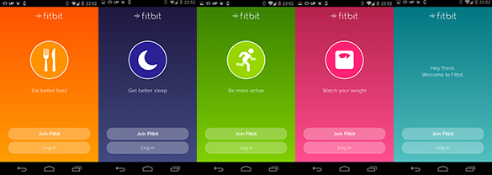

Figure 7: Possible Fitbit App Login Screens

* 1. If using a pre-generated Clinic or Patient account press ‘Log In’; then skip to step f.
  2. If you need to create a new account click ‘Join Fitbit’ and follow the prompts.
     1. when asked for an email and password generate the appropriate Fitbit account and password for patient as per Appendix B: Fitbit Account Username + Password Generation Procedure
     2. make sure to de-select the ‘Keep me updated about Fitbit products, news and promotions’
     3. make sure to select the ‘I agree to the Fitbit Terms of Service….”
     4. then click ‘Create Account’
     5. fill out patient information as best as possible.
        1. It is important to get First Name, Last Name and Gender correct.
        2. All other fields are not used and can be updated later.
     6. press ‘next’ to agree to the security agreement
  3. Associate a device with this account:
     1. If there is no device already associated with the account used, you will be automatically prompted to set one up; then skip to step v.
     2. If you are not automatically prompted to set up a device and need to set one up click the account info icon in the top right corner of the Fitbit app home screen.

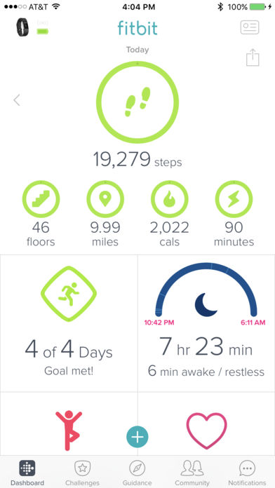

Figure 8: Top Section of Fitbit App Home Screen

* + 1. Once in the account info screen look under the ‘Devices’ heading for a ‘+ Set up a Device’ option. Tap this to set up a new device.
    2. If prompted select ‘Add a new Device’ or ‘Replace XYZ’ (to replace an existing activity tracker of model XYZ) as appropriate.
    3. Follow the rest of the device specific on-screen instructions to connect device to account

1. Verify the Fitbit account by logging into the email address registered and clicking the account verification link in the email sent by Fitbit
2. Finalize setup by giving Medly permission to access data from the Fitbit account used. Continue setup from Medly + Fitbit Account Linking: Dashboard Step 1)

## Medly + Fitbit Account Linking: Dashboard

The following are instructions for linking a patient’s Medly account and Fitbit account using the Medly Clinical Dashboard.

1. Log in to Medly (using an account with Clinical or Administrator privileges)
2. Find patient
3. Navigate to the patient’s ‘profile’ tab
4. Find the ‘Activity Tracker’ heading (scroll all the way to the bottom)

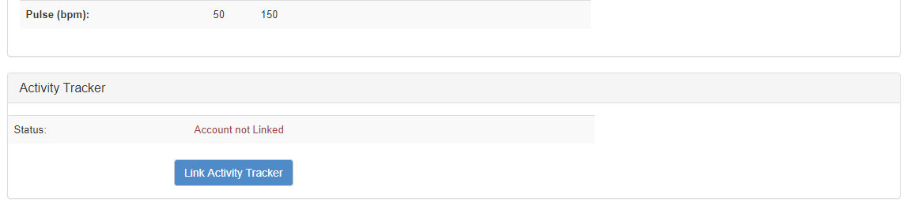

1. Click on ‘Link Activity Tracker’. This will bring up the following dialog box with instructions:

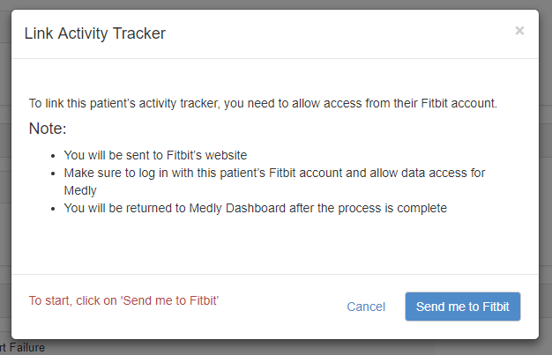

1. Once you have read the instructions start the process by clicking on ‘Send me to Fitbit’
2. From the Medly Dashboard you will be redirected to a login page on the Fitbit website:

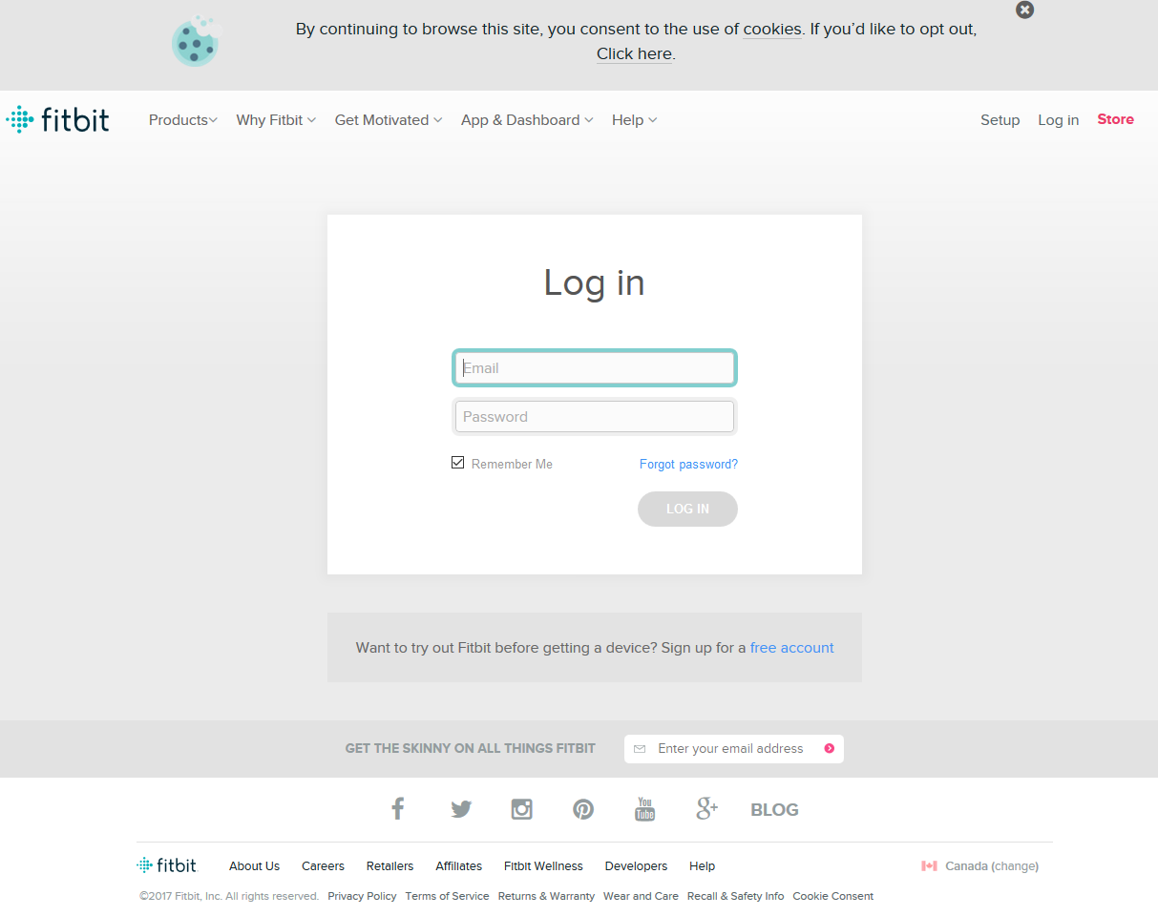

1. Using this login page enter the username and password for the patient’s Fitbit account; this may be the clinic generated & owned Fitbit account or the patients’ personal Fitbit account (as per Table 1 - the Device & Account Provision Matrix) and log in.
2. You will be presented with a list of the data access permissions requested by Medly.
   1. Make sure that all the checkmarks are selected (red bracket)
   2. It is good practice to double-check that you are logged into the correct account (purple arrow) – here we are logged into ‘phittools@ehealthinnovation.org’.

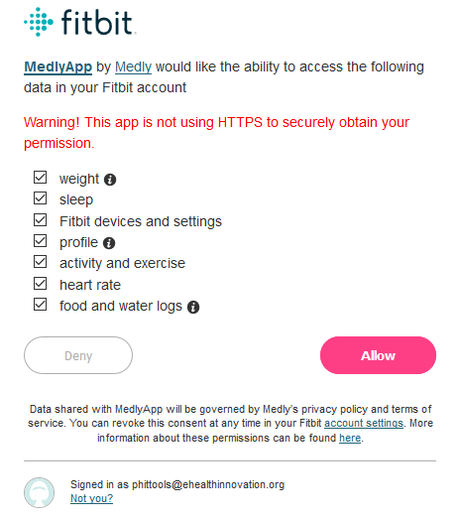

1. After verifying the permissions page click the ‘Allow’ button; you will be redirected back to the dashboard.
   1. If the linking was successful you will see the following page. In this example we have linked an account belonging to a ‘Jonathan Baril’. Click on ‘Return to Patient Profile’ to continue.

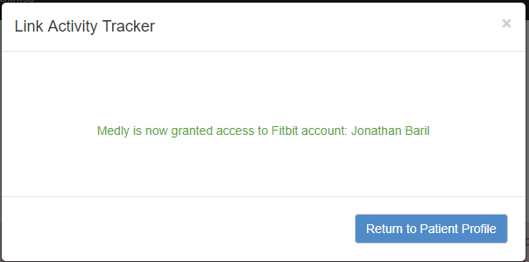

* 1. If there was a problem with linking you will see the following page. Try to resolve the problem using the instructions on the error page. If the error persists contact the development team.

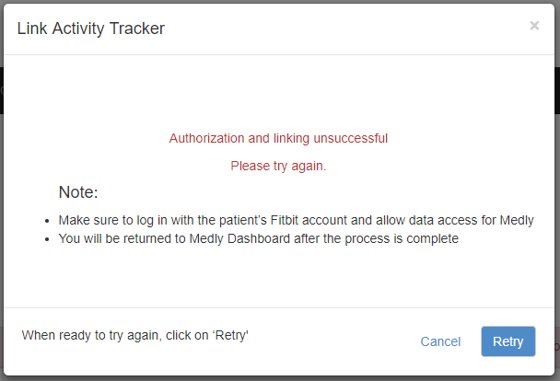

1. After successful linking the ‘Activity Tracker’ section of the patient’s profile will look similar to this:

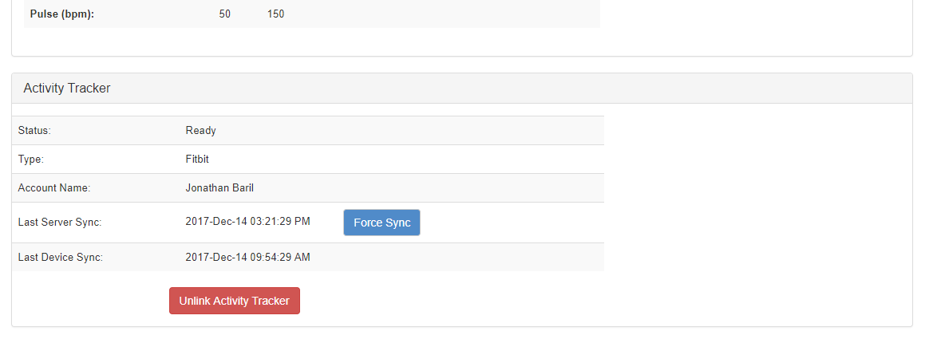

1. Setup is complete
   1. Remind patients whenever possible that they need to open this app regularly (i.e. on a daily basis) to ensure that data is synced to Fitbit and made available to Medly.

# Appendix A: Frequently Asked Questions (FAQ)

The following is a list of frequently asked questions or troubleshooting requests. Provided with each question is either a list of answers, responses or tips relevant to the question or a link to a resource that be referred to the patient (or used by Tech Support) to hopefully help resolve the inquiry.

## General & Device Specific Help Page

General Help: <https://help.fitbit.com/>

Charge HR Help: <https://help.fitbit.com/?p=charge_hr>

Charge 2 Help: <https://help.fitbit.com/?p=charge_2>

Alta HR Help: <https://help.fitbit.com/?p=alta_hr>

## Quick Links

|  |  |
| --- | --- |
| **Topic** | **Link** |
| General Help | <https://help.fitbit.com/> |
| Setup | <https://help.fitbit.com/articles/en_US/Help_article/1873/> |
| Getting Started | <https://help.fitbit.com/?l=en_US&c=Topics%3AGetting_Started> |
| Troubleshooting | <https://help.fitbit.com/?l=en_US&c=Topics%3ATroubleshooting> |
| Syncing | <https://help.fitbit.com/?l=en_US&c=Topics%3ASyncing> |
| Battery & Charging | <https://help.fitbit.com/?l=en_US&c=Topics%3ABattery> |
| iOS Fitbit App | <https://help.fitbit.com/?l=en_US&c=Topics%3AiOS> |
| Android Fitbit App | <https://help.fitbit.com/?l=en_US&c=Topics%3AAndroid> |

# Appendix A: Fitbit Hardware Labelling

Since the activity trackers used with Medly do not have a physical identifier that allows us to easily differentiate devices it is useful for various purposes to tag the devices used. The following table provides the requisite details for consistent tagging of devices.

Note that in the table the character string “###” is used to signify the unique serial number assigned to the device, whereas the string “#” is used to indicate the numerical subset of the unique serial number (which should be an incrementing number without padding). As an example for a unit tagged as fitbit-chr-123, ### would be the abstract representation of the whole serial number string ‘fitbit-chr-123’ whereas # would represent only the 123 portion.

|  |  |  |
| --- | --- | --- |
| Device Type | Serial Number Format | Label Location |
| Fitbit Charge HR | fitbit-chr-# | Outward face of band below display.  Bottom of number on the left side of the band (side of the tracker with the button.)  Note: do not obscure display.  Image result for fitbit charge  S/N: ### |
| Fitbit Charge 2 | fitbit-c2-# | Outward face of band below display.  Bottom of number on the left side of the band (side of the tracker with the button.)  Note: do not obscure display.  Image result for fitbit charge  S/N: ### |
| Fitbit Alta HR | fitbit-Ahr-# | Outward face of band below display.  Bottom of number on the left side of the band (when looking at the front)  Note: do not obscure display.  Image result for fitbit alta hr  S/N: ### |

# Appendix B: Fitbit Account Username + Password Generation Procedure

One of the complexities of managing Medly + Fitbit is that users require an additional Fitbit user account above and beyond their Medly account. To alleviate administrative and user burden a user’s Medly account and Fitbit account username and password should be the same (as much as possible). In order to simplify and unify the process please adhere to the procedure outlined below.

Note that Fitbit account username (i.e. email) and passwords are to be stored along with the patients medly username and password in the master password document maintained by Tech Support.

## For patient provided Fitbit accounts:

The setup process is fairly simple when using patient provided Fitbit accounts since the patient will have already established the Fitbit account username and password, which will forcibly differ from the medly account. As such we simply need to document as much of the information that the patient is comfortable providing:

1. Make sure to document this information (with email and password if possible) in the master password document.

## For clinic provided Fitbit accounts:

The setup process for clinic provided accounts is a little bit more involved since it involves generating the email address, username and passwords required:

1. Generate a medly account name as per the existing procedure.
2. Generate a password for the medly account as per the existing procedure. This will also be the password used to secure the Fitbit account and associated email.
3. Given a medly account name in the format ‘medly#’ where the string “#” is used to indicate the unique number appended to the user account (e.g. # = 123 for account ‘medly123’) generate a user email address in the format [medly#@medly.ca](mailto:medly#@medly.ca) by submitting a Freshdesk ticket.
4. Use the generated email and generated password to create a Fitbit account (either using the Fitbit website or as part of the procedure outlined in Device Setup: Phone Step 2)e